Informatica Project activity -

Source Mapping-

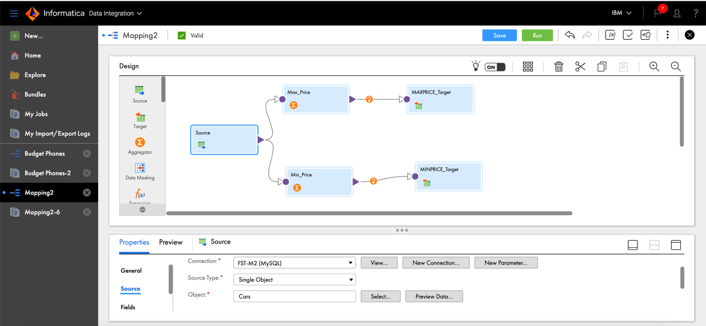

Aggregate 1 Mapping-

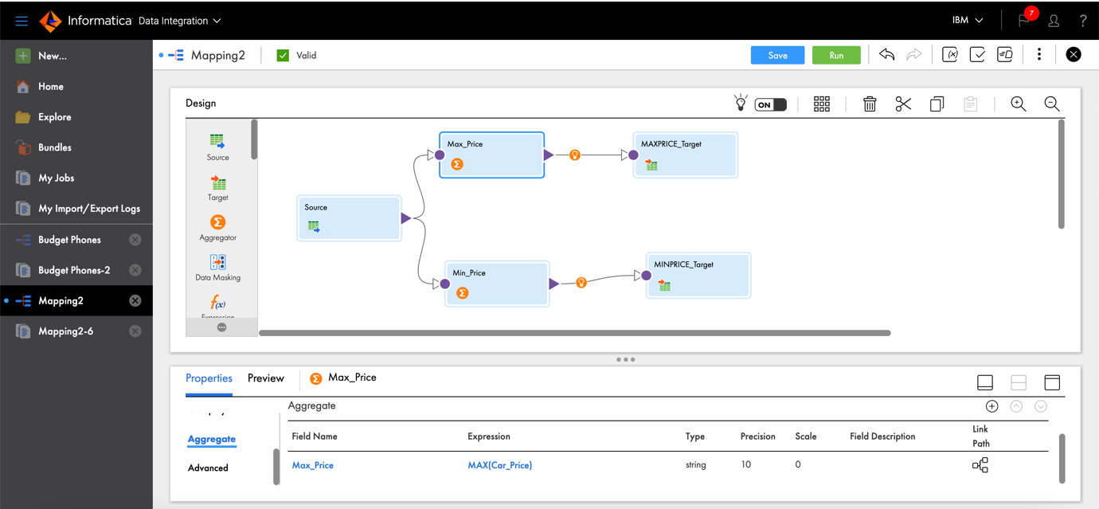

Aggregate 2 Mapping-

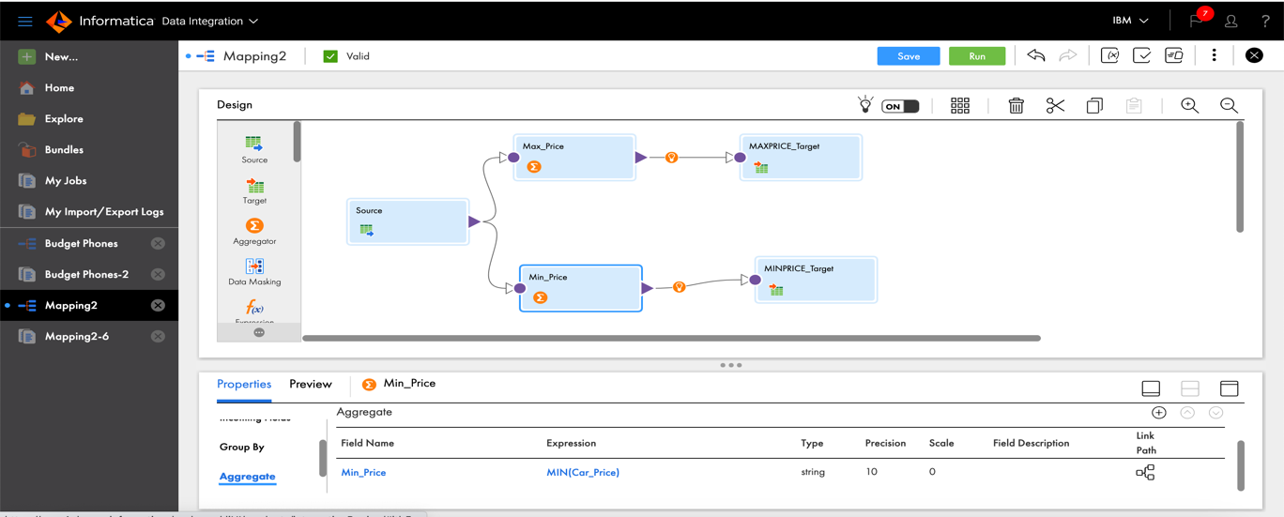

Target 1Mapping -

Target 2 Mapping -

